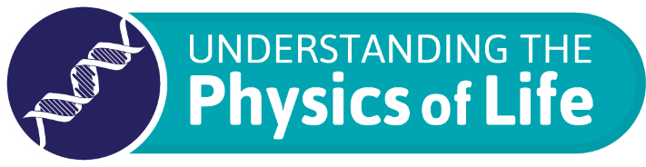

PoLNET3 Workshop Application Form
Physics of Life Network 2020-2023
Applicant details
Name of lead applicant(s)

Institute and dept. affiliation(s)

Email(s)

Workshop Details
Title of workshop:

Workshop overview (including background and rationale)

What are the key questions that this workshop will address?
Workshop outputs e.g. links to new collaboration, grant applications and publications

Engagement potential, please outline which activities you will include in the programme to engage participants and promote cross disciplinary questioning.

Are you planning on running this workshop as a virtual or onsite event?

Proposed date and venue

Breakdown of expenditure
Please provide a breakdown of the proposed budget. See below for further details.
Where possible, please provide information on key potential speakers, specifying whether UK, EU or international and their anticipated associated costs (accounting for travel/accommodation).
Length of workshop (i.e. one, two day).
Expected workshop size (e.g. suggested number of participants).
Other anticipated expenditure (where known e.g. including venue info, catering):
Additional sources of income, please indicate any other sources of anticipated or secured co-funding.
Total PoLNET funds requested
*Note £5K can be awarded for a two-day workshop

Which of these Journals could you align with this workshop?
Interface ☐
iScience ☐
Physical Biology ☐

Funding and Reporting

For any questions related to the planning of your event or completion of this form, please feel free to email k.h.baker@dur.ac.uk.

Organisers of approved events will be expected to provide a written final report within six months of the completion of the event. A report form will be provided.

Reasonable standard class travel and subsistence expenses for invited speakers will be reimbursed directly by the Network following the event.

Please send this completed application form along with any additional information to k.h.baker@dur.ac.uk. Once received, a confirmation email will be sent, and your application will be considered within one month of submission.

